Family Health History
Software Test Plan

Prepared By
Khalid El-Amin
Incremental Software Solutions
November 02, 2009

Signature Page

Prepared By:
Khalid El-Amin  Software Analyst |  | Date
Reviewed By:
Requirements Analyst |  | Date
Approved By:
Project Manager |  | Date

Document Management

Revision | Date | Description
1 | 11/04/09 | Added figure one, modified reference list, add test case list, add browser specific information
2 | 11/09/09 | Add FHH specific testing information/Remove Health Vault Specific Information
3 | 12/23/09 | Updated the test plan to incorporate BETA Testing in appendix A
4 | 12/24/09 | Update Changes to test approach

Table of Contents
1.Introduction 5
1.1Background ………………………………………………………………………………………………………………5
1.2Objective of Testing……………………………………………………………………………………………………….5
1.3Purpose of Testing…………………………………………………………………………………………………………5
1.4References…………………………………………………………………………………………………………………….5
1.5Intended Audience…………………………………………………………………………………………………………5
2.Test Approach 6
2.1Software Test Strategy……………………………………………………………………………………………………6
2.1.1Testing Process…………………………………………………………………………………………………………….6
2.1.2Testing Steps………………………………………………………………………………………………………………..6
2.1.3Functional Testing………………………………………………………………………………………………………..7
2.1.4Features to be Tested…………………………………………………………………………………………………..7
2.1.5Types of Testing…………………………………………………………………………………………………………..9
3.Test Instance 10
4.Test Documentation 10
4.1Software Testing……………………………………………………………………………………………………………10
5.Entry and Exit Criteria 12
5.1Entry Criteria…………………………………………………………………………………………………………………12
5.2Exit Criteria…………………………………………………………………………………………………………………...12
6.Test Deliverables 12
7.Staffing Needs 12
7.1Staffing………………………………………………………………………………………………………………………….12
7.2 Schedule……………………………………………………………………………………………………………………..13
Appendix A………………………………………………………………………………………………………………………14
8. Beta Testing…………………………………………………………………………………14
8.1 BETA Test Approach…………………………………………………………………………………………………14
8.2 BETA Test Process……………………………………………………………………………………………………15
8.3 BETA Test Steps…………………………………………………………………………………………………………16
8.4 Features to Be Tested………………………………………………………………………………………………17
8.5 BETA Test Environment……………………………………………………………………………………………..18
8.6 BETA Test Deliverables………………………………………………………………………………………………18

Introduction

Background
This project is to demonstrate that that the user can save a family history and open a family history in the Family Health History application. This project is to also demonstrate the ability to maintain Family Health History functionality after changes are applied to the code and major third party integrations such as Health Vault.

Objective of Testing
The objective of the agile software integration testing of the Family Health History is to uncover any deviations from the requirements and to verify that all requirements that have been defined by the stake holders’ are incorporated in each release and work as designed. This effort will also assist by providing continual product quality improvement and maintain the level of software quality standards as prescribed by the stakeholders and system owners.

Purpose of Testing
The purpose of agile software testing is to communicate and uncover any deviations between the documented functional requirements, and the software application. The testing initiative will be used to establish an automated test base line. Any functional deviations will be identified and reported as software incident reports during product integration. After the successful execution of identified test cases test results will be reported to the development team through the Jira issue tracking system.

References
FHH Vision Software Data Elements
Fhh supplementary specifications
FHH User Experience Specifications
FHH Look and Feel Specifications
FHH Model Summary

Intended Audience
Individuals responsible for reviewing all proposals for this software are the intended audience for this document. This may include 5 Am Solution Development staff, Incremental Software Solutions Staff and any individual who may be responsible for maintaining and supporting the current application.

Test Approach

Software Test Strategy
The Software Testing Resources will create automated test cases which will be based on the functional requirements communicated by the stake holders. The test cases will reflect the use cases that are created by the Requirements group and modeled using UML. The test cases will be created using the Selenium automation tool. Each automated test cases will be executed in the test environment to uncover all software defects. Once the automated test cases have been successfully executed they will be delivered to the developers for approval. Once approval has been granted the automated test cases will be checked into subversion to be executed. All of the software defects will be marked with unique identifiers when logged into the JIRA system and reported to the development team to be fixed and evaluated. All updates to the test case baseline will be maintained by the Software testing resource.

Testing Process

- At the start of the software iterations a planning meeting will occur that will outline all new software rules and new cards will be assigned as new functionality is added per release.
- All functionality and cards that represent requirements will be automated in the Selenium test suite repository.
- The test case repository will be updated, maintained and used as a regression test suite to ensure that with the addition of new functionality all existing functionality works as designed.
- After the code changes are built to the test environment and the test cases have been automated testing will begin.
- The software testing resource will report all test results at the completion and provide daily updates at the daily standup and program specific meetings during iterations.
- Once the test cases have executed successfully against the test environment. Once approval is granted from the development team the automated test cases created in Java will be checked into subversion.
- At the completion of a development iteration all results will be updated to the test repository with supported testing artifacts.
- All software incidents are to be document and reported to the development team and tracked through the Jira system and maintained in the Requirements Variability Traceability Matrix (RVTM).

Testing Steps

- During implementation review meetings all assigned functionally will be communicated per iteration and assigned as cards per iteration.
- Automated Test cases will be created and imported into the Java environment created to verify each requirement.
- The local test environment will be built and maintained by the testing resource.
- Addition of new test scripts and maintenance of the existing test case baseline will be maintained by the testing team.
- After the selenium test scripts are created in the selenium IDE. The scripts will be imported into the Java test class.
- Once the scripts are imported into the Java test class they will be executed from command line script and ran against a local build of the Family Health History web application.
- All input data *.xml files and export *.xml files will be used for data driven testing and will be imported into the automated test scripts.
- Once the scripts have successfully executed against the test environments the diff of the new files against the old files will be submitted to the developers for approval.
- Once approval has been granted by the developers the new automated scripts will be checked into subversion.
- At the completion of testing stake holder sign off will be obtained during the implementation review.

Software Integration Testing
During Software Integration Testing (SIT) the automated test case Base line will be executed to address the documented requirements and businesses cases. Each test case will be executed to ensure that the web application works as designed. The software testing will coincide with the development phases as outlined in the referenced project plan documents. The initial phases after the inception phase will consist of FFH export, FHH Import and later phases will consist of Health Vault import and data export. The development of automated test cases and baselines will mirror the project phase and scheduled functionality outlined in the Project Plan and referenced above.

Test Scenarios and Scripts
This section of the Test Plan will assist the users in the development of the required automated test scenarios.

Features Tested
The following features are being tested during each release of all phases. A list of each feature is described below:

Phases | Feature | Description
Phase I | Inception Phase | Initial test plan phase for creation of preliminary automated test cases and test environment.
Phase II | Establish Connection to Health Vault | Testing of refined requirements and changes to the initial code base..
Phase III | Testing of MFPH – Health Vault Data Import & Export | Testing of refined requirements, testing of all collaborated stakeholder requirements. The testing of HL7 pedigree message to get things and put things for Microsoft Heath Vault health histories and items using the communication interface
Phase IV | Conduct BETA Testing of all features | Execution of BETA testing of all production required functionality.
Phase V | Support NCI deployment team | Conduct any requested testing as requested by NCI

Types of Testing
Table 2 Types of Testing
Test Type | Test Description | Test Environment
Functional Testing | An investigatory testing phase, where the focus is to have almost a destructive attitude [and tests not only the design, but also the behavior and even the believed expectations of the customer. It is also intended to test up to and beyond the bounds defined in the software/hardware requirements specification(s). One of the primary goals is to update and establish an automated baseline to support regression testing. | Test Instance
Regression Testing | Ensures that changes made to an application do not impact the processing of existing applications. This is done by identifying those applications deemed critical to the daily operations of Oracle and by identifying the critical path. The same job stream would be run for every test cycle to establish a baseline for comparing results consistently. | Test Instance
BETA Testing | is the final component of the testing activities that occur throughout the development process, including: | Beta Test Instance
User Acceptance Test (UAT) | Consists of activities designed to verify, independently, aspects of the functionality tested during SIT (e.g., startup, operations, and external interfaces). UAT provides the system owner with an independent assessment that helps the system owner determine the system’s fitness for implementation. UAT is designed to meet user requirements. | UAT Instance
Exploratory Testing | This allows the tester to create test cases using his/her own knowledge of the product application to yield nontraditional use within the guidelines of the software functionality. | Test Instance

Test Instance
The test instance for Software Integration testing will emulate the production instance. Testing will be performed in-house. The configuration for testing should include the following:
- FHH will adhere to the XHTML 1.0 transitional standards as recommended by the World Wide Web Consortium (W3C). This standard is supported by most modern browser versions.
- The automated test scripts will be created from a local build of the FHH application. The configuration consists of Jboss, Maven, SQL and Java and eclipse.
- The test instance will consist of Firefox 3.5.3 and the latest Internet Explorer Browsers.

Test Documentation

Software Testing
All test cases will be documented in the standard format automated in Selenium and stored in a test case repository.

Table 4 High Level Sample Test Case list

Req. #/Cards # | Date Executed | Subject | Test Name | Blocks | Expectations | Observed Results/Comments | P/F | Tester
1/645 | 11/04/09 | Selenium Test: load a family history in Hl7 format and add a condition to a relative | FHH-645-TCS-1 | No | After the script execute the user should see the family loaded to the site and the condition will be added to a relative. | This test ran correctly | Pass | Jon Doe
2/646 | 11/04/09 | Selenium Test: load a Family History in HL7 format and remove a condition | FHH-646-TCS-1 | No | After the script is executed by the user. The user should verify that the condition is removed. | This test ran correctly | Pass | Jon Doe

Entry and Exit Criteria

Entry Criteria
Entrance criteria for testing are as follows:
- Test tools and test data ready and verified
- All support personnel identified and contact lists available
- Test environment ready and configured
- Software Test Schedule completed

Exit Criteria
Exit criteria for testing are as follows:
- All scheduled tests are executed
- Test cases are completed
- All Critical defects are closed
- All Critical defects have a resolution status or action plan toward resolution

Test Deliverables
The following documents will be delivered after successful completion of testing and final approval from the stakeholders.
- Software Test Plan
- Automated Test Scenarios and Test Cases
- Software Test Incident Report
- Software Test Summary Report (optional)

Staffing Needs

Staffing

Test Lead – will develop automated system and regression tests (functional and non-functional), execute the tests, set up and execute the beta test, and report results.

Schedule
The testing schedule will be documented in the software testing project plan.

Appendix A

8.0 BETA Testing

8.1 BETA Test Approach
The FHH BETA phase will mainly focus on the main application functionality and product integration specifically Microsoft Health Vault. Beta testing will be performed in an environment which should include all application configurations, components and affected software applications. The BETA test phase will verify that the software application meets the designed application functionality, and the product meets the needs of the end users. BETA testing will be performed in a production like environment.
In order to gather BETA test feedback efficiently and uniformly, we will use a web-based survey tool such as Survey Monkey to solicit input from the BETA testers. Questions will address overall satisfaction with MFHP, use of use, ability to perform required tasks, problems encountered, and suggestions for future releases.

8.2 BETA Testing Process
The results of the tests provide pertinent information related to the quality of an application and enables corrections to an application and quality improvements prior to production. To minimize risk and help reduce cost and schedule impacts, it is imperative to provide effective communication links between all of the product team members so that they can clarify and resolve issues and manage critical functional changes through the internal software development process.

8.3 BETA Test Steps
The Figures shows in detail the BETA test responsibilities, activities, input and output.

Process | Activity | Input | Output | Participants
P 1 | Verify that the Test Plan and Test Cases previously developed in the Requirements Analysis Phase | System Requirements Document  BETA Test Plan  BETA Test Scenarios and Test Cases  BETA Test Environment  Software Build Plan  SLA | BETA Plan | Product / Application Development  BETA Test Team  Project Manager  Technical Support
P 2 | Schedule Beta test executions | System Requirements Document  BETA Test Cases  SLA | Identification of Testing Functions and Dependencies  Test Case Requirement Traceability  Test Timing Schedules  Change Management | Product / Application Development  BETA Test Team
P 3 | Prepare test environments | Testing Functions and Dependencies  Testing Resources  Test Timing Schedules  BETA Test Cases | Obtain Test Resources  Implement Test Connectivity  Prepare environment-specific deliverables  Identify environment initialization variables | Product / Application Development  BETA Test Team  Systems Architecture
P 4 | Execute Test Cases according to BETA Test Plan and Test Cases | BETA Test Plan and Test Cases  Tests Process  Test Pass Criteria  Test Timing Schedules | Document and analyze results of each test  Create Progress Reports | Product / Application Development  BETA Test Team
P 5 | Review Test Results | Results of each test | Test Results Reviews  Generate Change Requests if Test Results do not pass criteria  Create Progress Reports | Product / Application Development  BETA Test Team
P 6 | Identify and escalate issues | Use communication links between requirements, development, and testing teams for clarification and resolution of issues | Track Trouble Tickets  Update problems from creation through resolution | Product / Application Development  BETA Test Team
P 7 | Prepare Test Results Summary Report | Use all outputs and/or observations from test executions and issue resolutions | BETA Test Results Summary Reports  BETA Progress Report  BETA Test Log  Software Development Plan | Product / Application Development  BETA Test Team

Figure 2 Produces a High Level Document of the BETA Testing Phase Inputs and Outputs
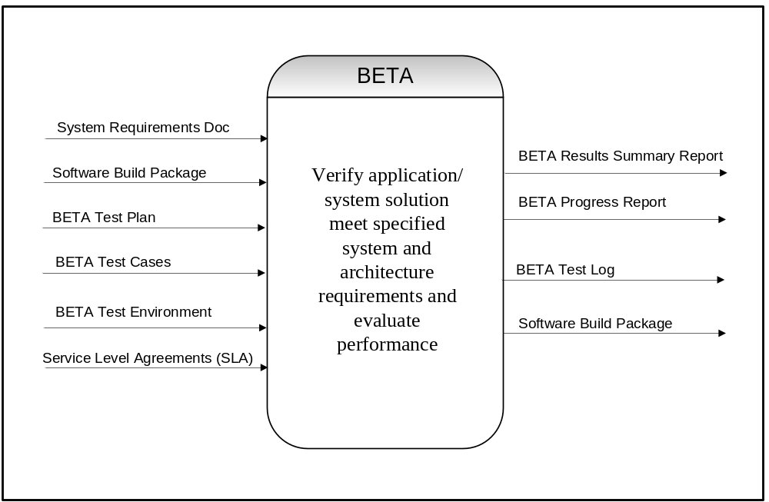

8.4 Features to Be Tested

Requirement Number | Description | Test Environment
4.5.2 | Save and download Family Health History | BETA
4.5.3 | Add an undefined disease | BETA
4.5.4 | Create Personal Profile | BETA
4.5.5 | Create Edit Family Member Health History | BETA
4.5.6 | Associate a disease with a family member | BETA
4.6 | View Pedigree Chart | BETA
4.6.1 | Define Chart | BETA
4.6.2 | Download Chart Table | BETA
4.6.3 | Print Chart Table | BETA
4.6.4 | View Chart Table | BETA
4.7 | Export Family Health History to Health Vault | BETA
TBD | Change the Site to Spanish | BETA
TBD | Import Family Health History | BETA
TBD | Third-party access to Family Health History | BETA

8.5 BETA Test Environment
The test instance for Software BETA testing will emulate the production instance. Testing will be performed in-house and at selected BETA test locations. The configuration for testing should include the following:
-Our goal is to recruit testers with different operating systems such as Windows and Macintosh supported operating systems
-Our goal is to recruit testers with different client browser referenced in the FHH requirements document
-All components of the Family Health History Application

8.6 BETA TEST Deliverables
The following documents will be delivered by the Testing Resource and delivered to document source control after successful completion of BETA testing.
- BETA Test Plan
- BETA Test Scenarios and Test Cases
- BETA Test Incident Report
- BETA Test Summary Report
- BETA Tester Surveys

